SQL SERVER, FILE IMPORTATION PROBLEM
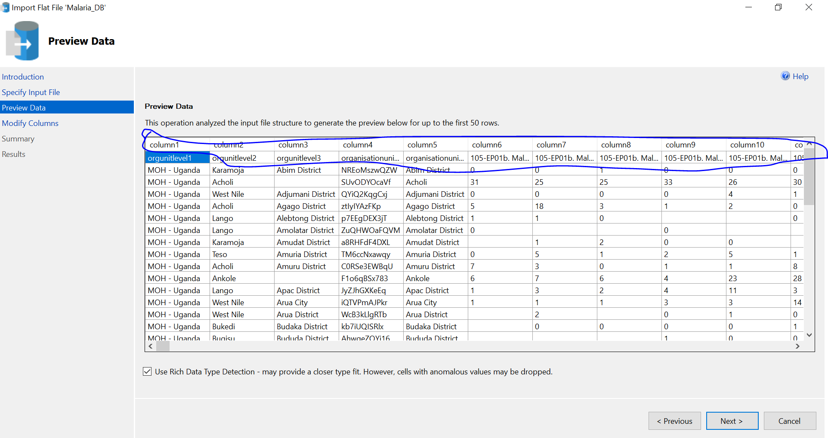
- On Importation of the flat files (Csv files), SQL server normally misplaces our original column names to row 2 with its own naming of columns, which makes it unsuitable for importation of large datasets that might contain cryptic/Variable column names.

